Simple Store Application

Overview
The Simple Store is a retail management system developed in F# using a Functional Programming approach. Its primary goal is to provide a reliable, maintainable platform for managing products and shopping cart operations through a structured, layered design

System Architecture & Components
The application is organized into a Layered Architecture to ensure a clean separation between data, logic, and interface:
- Domain Layer (Domain): Acts as the system's foundation by encapsulating core data into structured types like Records and Discriminated Unions. This defines the "shape" of products and carts used throughout the app.

- Logic Layer (Services): Contains the "brain" of the system. It uses Pure Functions to handle business rules, such as calculating cart totals and validating item additions, without affecting the user interface directly.

- Presentation Layer (UI): The Windows Forms graphical interface where users interact with the system . it captures inputs (button clicks, text entries) and displays outputs (receipts, totals) processed by the Services layer.

- Entry Point (Program.fs): The starting file that bootstraps the application and launches the main UI.
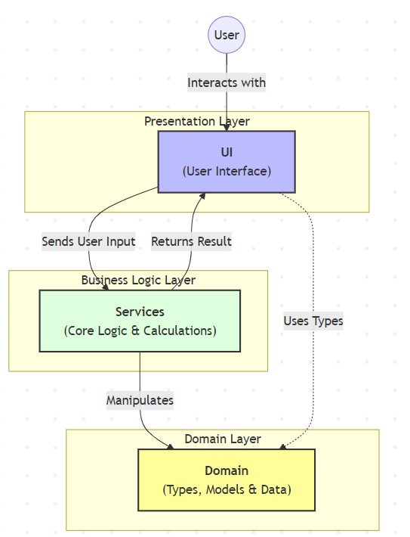
System Architecture Diagram

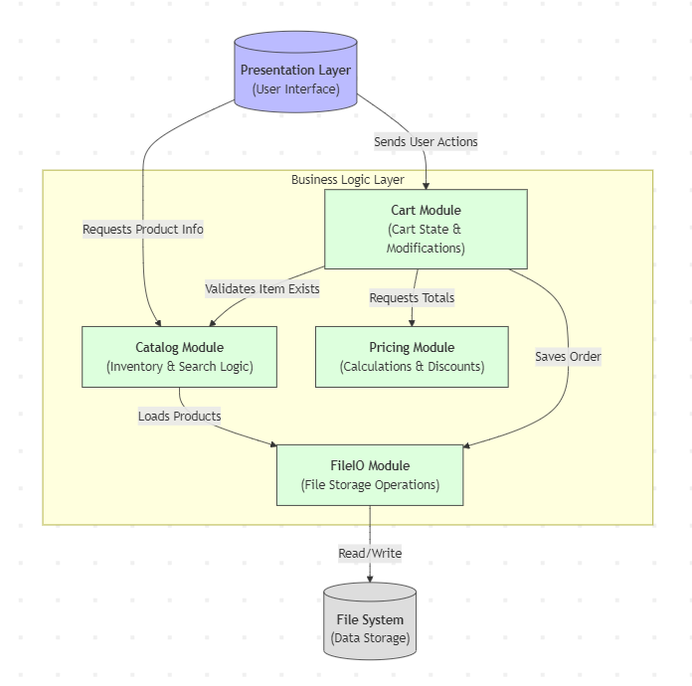
Business Logic Layer

Testing Strategy
The project implements a robust quality assurance plan using the xUnit framework located in the SimpleStore.Tests project:
- Automated Unit Testing: Specifically targets Services to verify that mathematical logic and business rules (like total price calculation) are 100% accurate.

- Manual UI Testing: Conducted on UI to ensure that buttons, text boxes, and labels interact correctly with the underlying logic and provide a smooth user experience.

